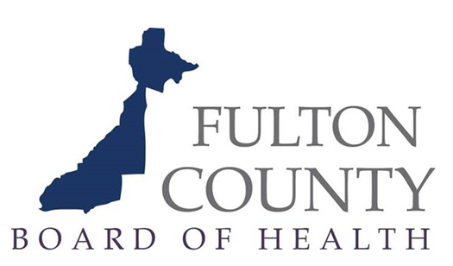

**FULTON COUNTY BOARD OF HEALTH**

**Regular Meeting**

**October 27, 2021**

The **Fulton County Board of Health** will hold its quarterly board meeting on October 27, 2021, starting at 10:30am. In response to the public health emergency and pursuant to O.C.G.A. 50-14-1(d)1, the meeting will be conducted via Zoom.

Anyone wishing to attend the meeting may make join virtually by logging in to:

<https://us02web.zoom.us/j/84581260994?pwd=M01SckdXYjFlcWVCTjhGQkoxSUh1dz09>

Meeting ID: 845 8126 0994

Passcode: =FCQz0K?

To join via teleconference please dial:

1(646)558-8656, enter passcode: 81720628582# OR 1(301) 715-8592, enter passcode: 81720628582#

Interested parties can submit comments in the following ways: 1. Type their comments during the virtual meeting using the Zoom chat box; 2. Email their comments to [Dorothy.Gaines@fultoncountyga.gov](mailto:Dorothy.Gaines@fultoncountyga.gov) or 3. Request before 5pm on October 26, 2021 to have access to address the board via Zoom.